**Problem 8:**

UPDATE LOCATION

SET LOCNAME = ‘Gate’

WHERE LOCNAME = ‘Door’;

**Snapshot for the Problem:**

1. **Before Updating the query**

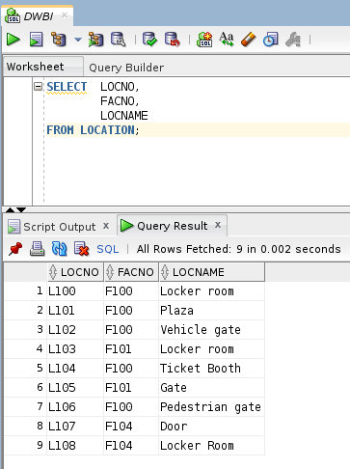

1. **Executing the Update query**

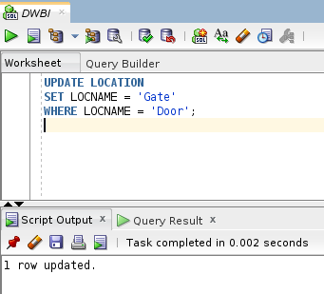

1. **After executing the query**